Arizona College and Career Ready Standards: These standards, both state and national, set the academic expectations of each ninth grade student. The national standards require a very high standard of reading, writing, speaking and listening. These standards will be addressed in my class throughout this year.
Materials:
- 3 ½ binder - will be provide for you by PHS and it is your responsibility to bring your binder to class each day.
- 2 highlighters
- Pencils- Pen

*AVID students are allowed to use their AVID binders if they have a large section for English.
FOCUS: Writing will be taught with a great emphasis on providing evidence for all of your claims, opinions and arguments. We will teach you how to back up your statements with evidence. As we read novels and nonfiction text we will respond by writing essays and or responses.
Literature:
1st Quarter = Nonfiction text and Short Story
2nd Quarter = Literature and U.S Seminal Documents
3rdQuarter = Novel- Lord of the Flies
4th Quarter = Research reading and writing

Grading System: Grading is based on accumulation of points. Writing is the key focus and will have the most value throughout the year. Each 9th grade student will have one essay due each quarter. We will give you points on assignments. For example, homework is valued at approximately 10 % of your grade and essays and writing assignments are weighted approximately 40%.. So essays and writing are very important in my class. We do give extra credit at student request, but not two weeks before the semester ends. The following will be the categories each student is graded upon.
Homework/classwork
Writing Process /Essay
Benchmark Assessments-Reading assessments (Tests)
Independent Reading Project
Final Test

Homework Policy:
Homework is every night. If there is not specific homework given for that day or week, students should be doing their Independent reading project. High school students should be reading for pleasure all year long. Homework will be given in order to improve academic performance through practice, preparation, an extension activity, or to provide students the opportunity to show their creativity. Homework for this class should not take students any longer than 30 minutes- one hour. The teacher, student, parent(s) must all take some responsibility in order for homework to be an effective educational tool.

Late Work Policy: We will accept all late work until or before the end of the semester, with a grade no higher than a 60%. It is your responsibility to talk to me about missing work.
WEBSITE ADDRESS: http://fitchsanddevils.weebly.com
CLASSWORK AND HOMEWORK WILL BE POSTED TO MY WEBSITE EACH DAY. IF STUDENTS MISS A DAY, PLEASE MAKE SURE THEY COME BY MY ROOM TO VERIFY THEIR WORK OR WHAT THEY ARE MISSING.

Classroom rules

- Student will be in the room before the final bell rings.
- Students will bring their binder each day
- Students will respect the teacher’s right to teach and student’s right to learn.
- Students will strive to give 100% each day they enter my class.
- Students will use impeccable words- please think before you speak in the classroom-as words can heal or hurt others.

Expectations of Students:
This class will reinforce the PRIDE expectations consistently. My hope is these expectations will improve the learning environment and increase student learning. I will make an effort to reinforce the PRIDE expectations by presenting the student with a PRIDE ticket while identifying the displayed behavior, attached with the specific expectation. For example: “Thank you for getting involved by actively participating in the activity today.”

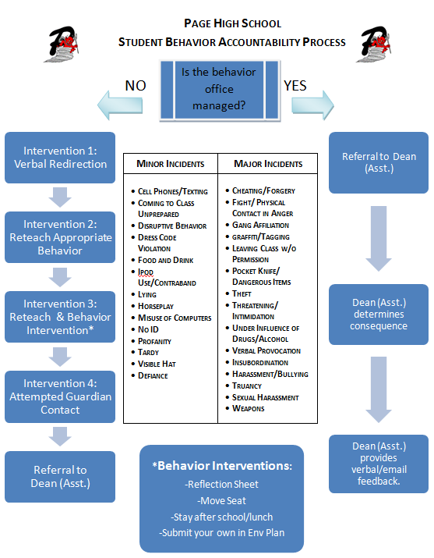
Discipline
Students are expected to follow all school rules in this classroom. These rules can be found in your Student Handbook.
Students who violate school rules will be held accountable through the posted accountability system. Major infractions will be referred to the Dean of Students immediately, while minor infractions will be enforced accordingly:
Consequences to Minor Incidents
1. Verbal Warning- Notification of incident
2. 2nd Verbal Warning- With a physical approach quietly – reteach/request thinking about behavior
- Intervention- move seat, asked outside for a conversation about problem with the teacher, or reflection sheet
- Call Parent – explaining problem and to get advice
- Referral to Dean- Major incidents could skip steps 1 through 4

Tardy Policy: Bell work is on the board every day before class. This work must be started at the bell. If you are not in your seat doing or getting ready to do bell work, you will lose points.
1ST Tardy- verbal warning
2nd Tardy-Re-teach- Reflection sheet – instructions on how to be on time- student feels out this sheet.
3rd- Tardy- Contact parent
4th Tardy- tardy- referral
__________________________________________________________________________________________________________________

Period _____________ 9th Grade English –Fitch

I, ________________________________________, understand the grading, tardy policy and general information listed on Ms. Fitch’s syllabus. I understand it is my responsibility to talk to Ms. Fitch about my grade. I understand it is my responsibility to give a 100% effort in Ms. Fitch’s class all the time.
Dear Parent,
We are very excited to have the privilege to teach your child. If there are any questions or concerns -please call us at 640-4100 Ext. 5184 or email me at kfitch@pageud.k12.az.us .
Page High School has provided your student with a binder to keep their core classes organized. The expectation is that students will bring this binder to their science, math and English classes each day. There will be a grade assigned for keeping their binder organized.

Parent Name __________________________ ______
Parent signature _______________________ ______ Date ______________
Student name _______________________________
Student Signature ____________________________ Date ______________

Teacher Signature _____K. Fitch ________ Date ____8/4/14_____
Teacher Signature ______E. Tenpenny_____ Date _____8/4/14

